P

Abstract

A request for the development of a mobile and web application for Jean’s Mobile Beauty and Wellness organization by Last Block Coders

Project Proposal

Jean’s Mobile Beauty and Wellness

Table of Contents

Client Description 2

Identified challenges with current operations 3

Client’s Needs: 3

Project Description: 3

Project Sponsor: 4

Project Personnel: 4

Project Manager 4

Quality Assurer 5

Development Team 5

Project Goals: 5

Acceptance Criteria: 5

Project Requirement Analysis 5

System 6

Functional 6

Non-Functional 6

External Interface 7

Project Deliverables: 7

Scheduled Objectives: 7

Analysis 8

Design 8

Development 8

Budget 8

Work Break Down Structure 9

Conclusion 10

Project GitHub Repository and ZenHub 10

Sign-off 10

# Client Description

Jean Mobile Beauty and Wellness is a personal care services organization operating in and around the Johannesburg Metropolitan City, Centurion and some parts of Pretoria. The company offers mobile beauty and wellness services, bringing their business to the clients’ door. The business operates on a by appointment-only basis and at a location chosen by their customer. They do not run brick-and-mortar operations.

The services offered by business range from female beauty services to all-encompassing wellness services, all of which provided on the go to their customers. Depending on the service, there might be specific requirements that a customer’s chosen service delivery location must meet in order to accommodate the equipment and staff that will be used, to deliver the best kind of service. It should be noted that Jean’s Mobile Beauty and Wellness only confirms this and many other additional information once the customer has shown interest in booking an appointment.

The type of clients the business takes on ranges from young adults to old age people, and they could be an individual or a large group of people. There is currently no limit placed on the number of clients the business can take on for a desired service, it is information that is only communicated upon enquiry. And Clients direct appointment request straight to Jean’s Mobile Beauty and Wellness through either voice call or WhatsApp chat and this is also the same with regards to enquiries.

Upon receiving a request, the business either accepts it or rejects over the call or chat and then payment details are discussed thereafter. When an appointment has been accepted the business keeps track of it using a basic calendar application, that will provide them with notification as the appointment date and time approaches. The payment of services currently happens through either an EFT payment, which the organization provides their banking details once an appointment is scheduled, or a cash payment upon arriving at the client’s location.

For advertising the business relies on their Facebook page, Google business listing and word-of-mouth. The Facebook offers minimal information on the services offered but it does direct potential customers to make a phone call for more information or make an enquiry through their WhatsApp business account. The Google listing also serves the same purpose and that about covers their online presence and marketing.

## Identified challenges with current operations

* Jean’s Mobile Beauty and Wellness does not currently have a website or application from which they can direct their customers to, even though it relies on an e-commerce business model.
* The business mostly relies on word-of-mouth advertising for their services. This presents a problem in that once a customer hears about the business, they have only a WhatsApp business account to view further information online and this relies on the business owner being able to respond to their enquiries.
* Due to appointments being made through chats or voice calls, the business is forced with having to accept or deny some services to their clients which may have challenging requests which the business may be unable to fulfil in time.
* Potential clients have no information on how these mobile services are carried out and what each service will provide; unless they direct all of their questions to the business owner.
* Customers also have no way of knowing if and when will they be able to make an appointment without consulting with the business owner first.

## Client’s Needs:

* Offer beauty and wellness services information in way that is appealing to potential customers
* Get communication or enquiries from clients directed to the business WhatsApp Account
* Get automatically processed appointments with the flexibility of being able to re-schedule or reject in case of unforeseen challenges
* Be able to accept bookings a week in advance
* Receive online payments with some cash options for specific services

# Project Description:

Our group, to be known as Last Block Coders, will undertake the task of creating a mobile web application that will not only help Jean’s Mobile Beauty and Wellness list and detail their services online but also provide their clients with an online appointment/booking system that can allow them to also process online payments.

We will develop applications that help the company in advertising their business, displaying information on their services and how it sets them apart to other business within their industry. Potential clients will be able to browse a service catalogue, make enquiries if needed and eventually make an appointment; including paying for it over the internet, allowing the business to only focus on delivering the best services.

We will have a front-end team and a back-end team with Last Block Coders. Our front-end team will be focused on developing the client application which is what Jean’s Mobile Beauty and Wellness customers will use to virtually interact and be able to engage with the business. They will also work on the admin application which the business will be able to use to moderate, modify and communicate with the client application; thereby its customers.

They will develop the UIs (User Interfaces), which is how everything will look throughout the applications and also the UXs (User Experiences), which will be how everything on the application will be layered and made functional. They will be using the JavaScript REACT and REACT-NATIVE frameworks to help them carry out these tasks. Google Analytics will be used for marketing areas of concern that the business will have.

The back-end team will be focused on working on the business logic of the applications including the administration of the database and APIs needed to communicate information between interfaces. They will help in providing the responses to the front-end system requests and its operations. The Python-based DJANGO framework will be used to build the back-end system. Once done this two systems will work together seamlessly to provide a mobile application that will hopefully push Jean’s Mobile Beauty and Wellness forward, enhancing their business operations and growing their client base.

# Project Sponsor:

Jean Mokgale – CEO of Jean’s Mobile Beauty and Wellness

# Project Personnel:

## Project Manager

Lesego Wayne Hartley

## Quality Assurer

Blessings Nyasulu

## Development Team

|  |  |  |
| --- | --- | --- |
| Role | Name | Contact Details |
| Back-end developer | Lesego Wayne Hartley | lesegohartley@gmail.com |
| Back-end developer | Lulama Shiringani | lulamashiringani.sl@gmail.com |
| Front-end developer | Motshidisi Pholoane | Mpolwayne19988124@icloud.com |
| Front-end developer | Blessings Nyasulu | nyasulublessings65@gmail.com |

# Project Goals:

* Deliver a functional client and admin application to Jean’s Mobile Beauty and Wellness
* Offer their customers an appointment booking system that is a simple 4 step process: select a service, choose a date and time, request an appointment and make a payment after confirmation of availability
* Increase interest in Jean’s Mobile Beauty and Wellness through some interactive menus that will encourage their customers to try out their services.
* Make it easy for Jean’s Mobile Beauty and Wellness to retain the interest of their already registered customers through email marketing.
* Help the business improve and evolve their marketing strategies with the help of using Google Analytics that will be captured when users interact with the application.

# Acceptance Criteria:

* Client application and CMS application
* SSL certificate confirming security of data
* The back-end and front-end systems communicating through APIs
* Clients booking system
* Business booking management system
* Online payments options
* Capturing and monitoring of analytics

# Project Requirement Analysis

|  |  |
| --- | --- |
| Category | Requirements |
| System | * Sign up and log in screen/page * Homepage/screen * Service Catalogue screen/page * Individual service information screen/page * Appointment booking form * Appointment information screen/page * User account screen/page |
| Functional | * Direct users to WhatsApp business chat * Sign up user accounts * authenticate users * Modify user account details * Display the services on offer * Add a new service to offer users * Modification existing services * Removal of a service * Create dynamic date/time for bookings * Create appointment booking requests * Process appointment requests * Modification of appointments/booking details * Generate booking/appointment invoice/details * Process online payments |
| Non-Functional | * Generate appointment details to add to third-party calendar applications * Host application on AWS * Green colour and brown palette to be used throughout the modern and soft design * Send notifications to the user and admin applications * Send email confirmations and communication to users |
| External Interface | * Google Chrome or any chromium browser for PC/Laptop/Tablet * Internet connection – 3G/LTE/4G/5G or WiFi * Android 4.1 and above * IOS 11 and above * 1GB RAM minimum * E-mail application * Calendar application * AWS Boto3 * AWS SS3 |

# Project Deliverables:

* Functional Model
* Database Design
* Structural Model
* Application Design
* Prototype Client Web Application
* Analytics & Admin Applications
* Installation guide
* User manual
* Training manual

# Scheduled Objectives:

The following will not accomplished sequentially but rather iteratively due to us employing agile design methodologies. **Therefore, some initial documents may be altered and/or modified with new information by the completion of the application.**

|  |  |
| --- | --- |
| Phase of Development | Objectives |
| Analysis | * Requirements Definition * Use Case Analysis * Business Process and Functional Modelling * Data Modelling * Structural Modelling * Behavioural Modelling |
| Design | * Database Design * Web UI/UX Design |
| Development | * Database and tables * Webpages and User Interfaces * APIs * Launching and hosting on AWS |

# Budget

|  |  |  |
| --- | --- | --- |
| Service/Feature | Description | Cost |
| AWS Location Service* | Securely and easily add location data to our applications | Free* - PAYG service after exceeding free resources or 12 month trial |
| AWS EC2 | Secure, reliable and scalable infrastructure on demand | Free* - PAYG service after exceeding free resources or 12 month trial |
| AWS S3 Bucket | Simple storage service | Free* - PAYG service after exceeding free resources or 12 month trial |
| AWS RDS | Highly available and secure database service | Free* - PAYG service after exceeding free resources or 12 month trial |
| AWS Amplify | Hosting service for fast, secure, and reliable static and server-side rendered apps that scale with the business | Free* - PAYG service after exceeding free resources or 12 month trial |
| AWS Pinpoint* | Multichannel marketing communication service | Free* - PAYG service after exceeding free resources or 12 month trial |
| ZenHub | Productivity management software | Free* |
| Icons8 | UI graphics for designing menus | $13 once-off |
| Pexels | UI graphics – images and backgrounds | Free |
| Total | | ~R214 |

# Work Break Down Structure

A screenshot of the detailed Work-Break-Down Structure:

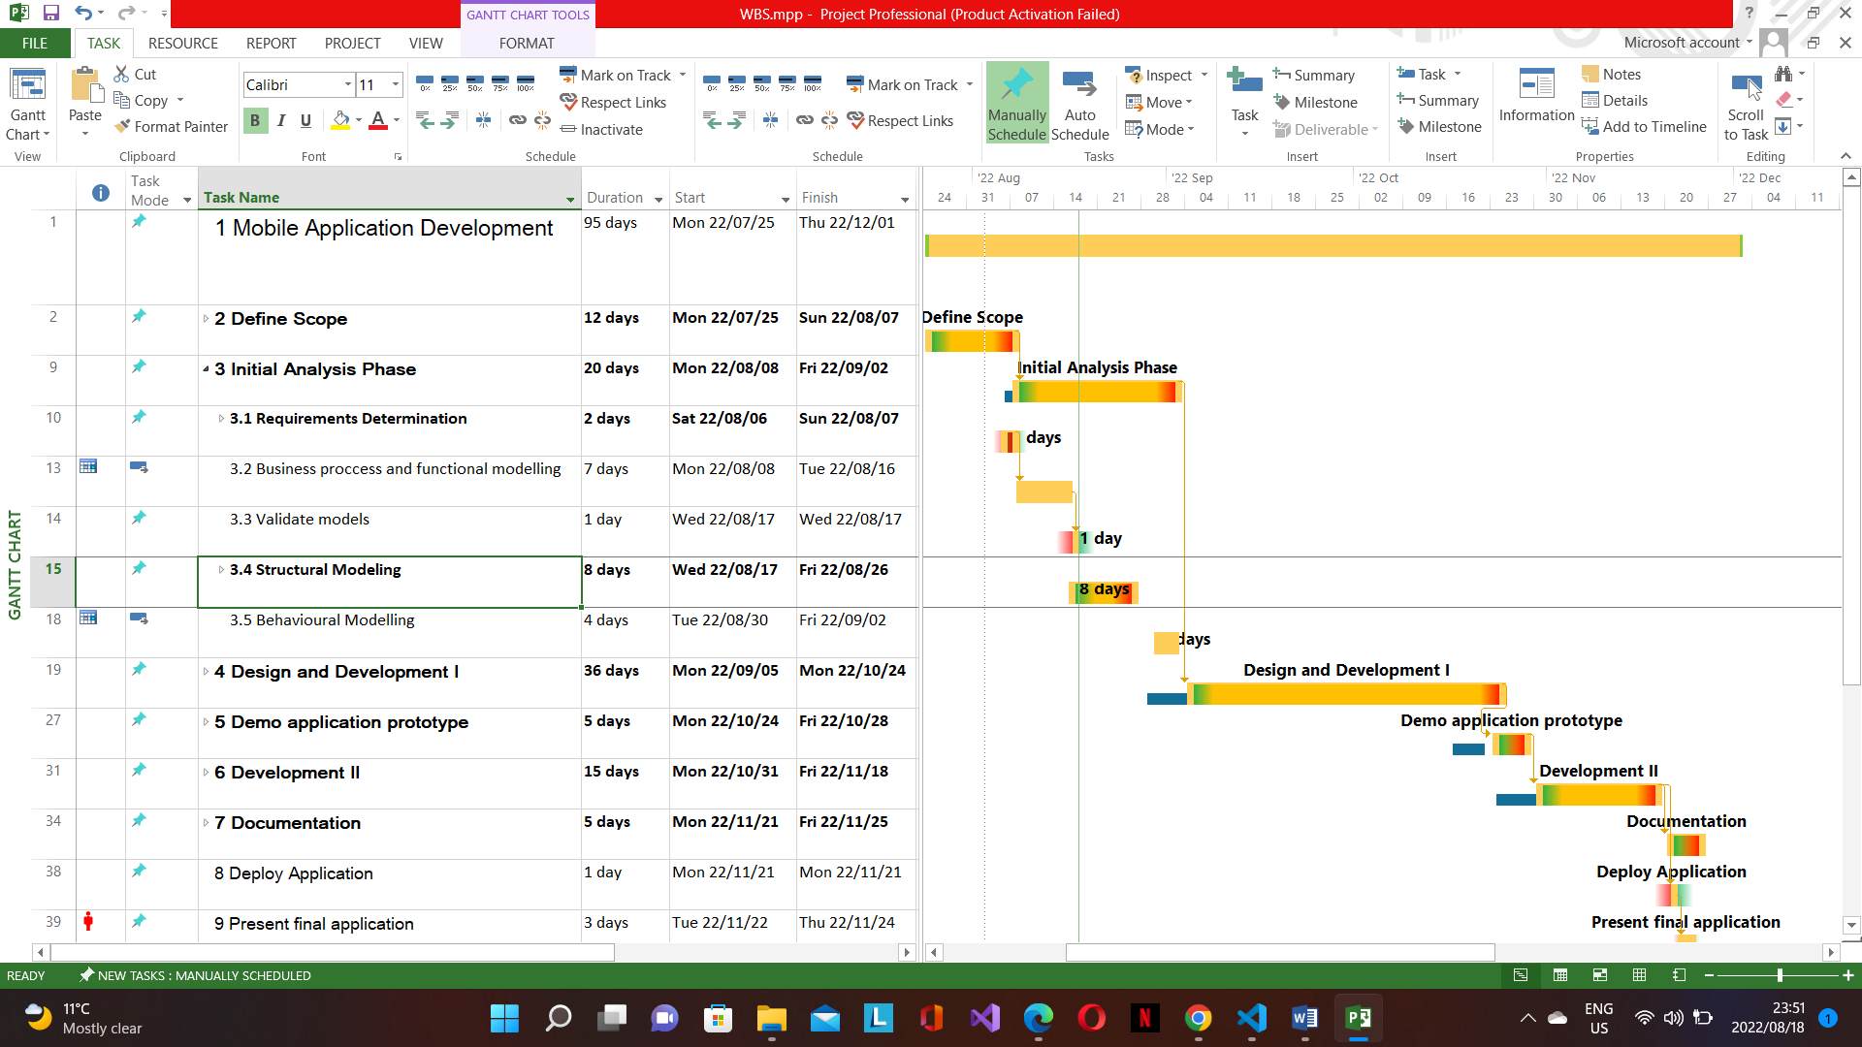

# Conclusion

## Project GitHub Repository and ZenHub

In order to document our work and enhance our productivity levels as group we will be using GitHub and Zenhub. GitHub to write, read and share documentation as well as to collectively write code. Zenhub will help us with carrying out our agile development by managing our productivity levels and making sure communicate any issues in a professional manner. Please note to protect our work we have made this repository private but can make it publicly available upon request.

<https://github.com/LastBlockCoders/Jeans-Mobile-Beauty>

# Sign-off

|  |  |  |  |
| --- | --- | --- | --- |
|  |  |  |  |
| Jean Mokgale, **Project Client**  Date: _____________________ |  |  | **Lesego Hartley, Project Manager**  Date: _____________________ |